Digital Signal Processing Task
Task1
Comprehensive Signal Analysis: Time-Domain and Frequency-Domain Techniques for Signal Processing
File name: Netra_50 MSPS.dat
- Upload path of file
# Load the data from the .dat file
samplefile = "/home/sandeep/Downloads/netra_50msps.dat" # Corrected file pathsample_bbbs_assignment_id100.dat

# Step 1: Read the data
with open(samplefile, "rb") as f:
Original_data = np.fromfile(f, dtype=np.complex64)

- This code reads a complex time-domain signal from a .dat file, defines the sampling frequency (50 MHz), and creates a time array. It then plots the original signal, displaying amplitude versus time. The x-axis represents time in seconds, and the y-axis shows the amplitude of the signal. This provides a clear visualization of the signal's behavior over time.
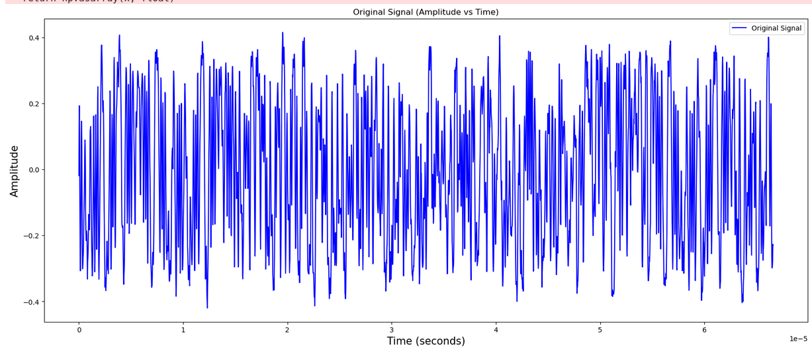
- plot spectrogram for the original data
- Number of samples: 3330
- Duration of the signal: 6.66e-05 seconds
- plots the spectrogram of the original data, providing a time-frequency representation of the signal. The x-axis represents time in seconds, the y-axis shows frequency in Hz, and the color intensity indicates the signal’s power (in dB) at each time-frequency point. The spectrogram helps visualize how the signal's frequency content changes over time.
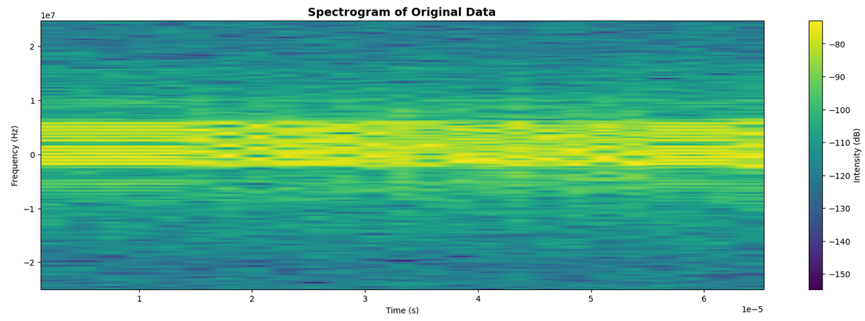
- Frequency Spectrum of Original data
- The FFT of the original signal was calculated using a size of Nfft​=2048, with fftshift applied to center the zero frequency. The spectrum, plotted as magnitude vs. frequency, highlights the signal's frequency components, showing both negative and positive frequencies. This provides a baseline for identifying any frequency offsets present before correction.
- The plot provides a visual representation of the signal's spectral content, indicating the presence of dominant frequency components.

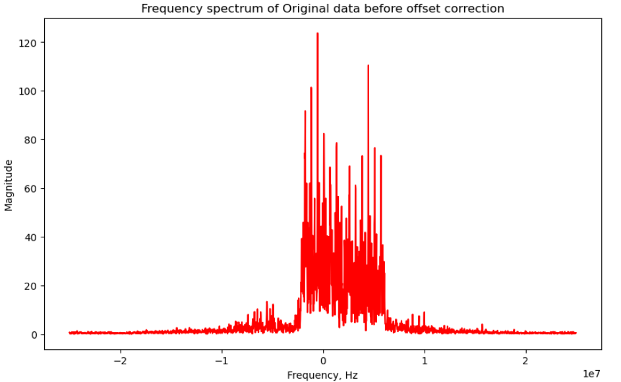

- Estimate Offset frequency
- Offset frequency refers to a constant frequency deviation (e.g., carrier frequency drift or DC offset). Identifying and correcting this helps align the signal properly in the frequency domain.

- Candidate band fstart: 6176757.81, fend: -2294921.88, bw:8.47 MHz
- Offset found: 1940.92 kHz 3330, offset=-1940917.96875, Fs=50000000.0
- Correct Offset frequency
- Frequency Offset Correction:
The detected frequency offset (offset_freq = 1.94092e6 Hz or 1.94 MHz) is compensated by multiplying the original data with a complex exponential (np.exp(-1j * 2 * np.pi * offset_freq * time)). This adjusts the signal to correct for the frequency shift.
- Spectrogram Plotting:
The plt.specgram function is used to generate and display the spectrogram of the offset-corrected signal (data). The plot shows the signal's frequency content over time, with the X-axis representing time, the Y-axis representing frequency, and color intensity indicating signal strength in dB.

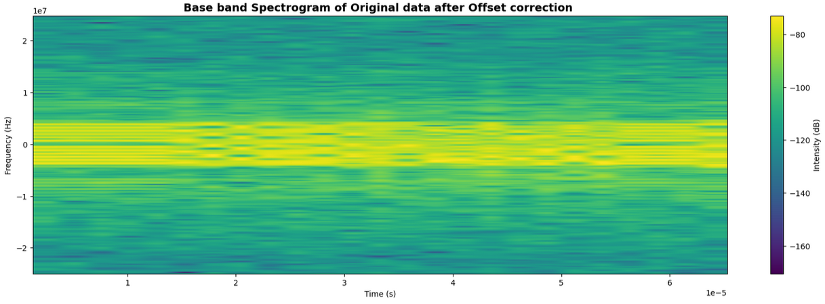
- Frequency Spectrum After offset correction
- Calculates the FFT(Fast fourier transform) of the offset-corrected signal (data) with an FFT size of 2048, shifts the frequency axis to center zero frequency, and plots the magnitude of the spectrum. The resulting plot shows the distribution of frequency components after the offset correction, with frequency on the X-axis and magnitude on the Y-axis.
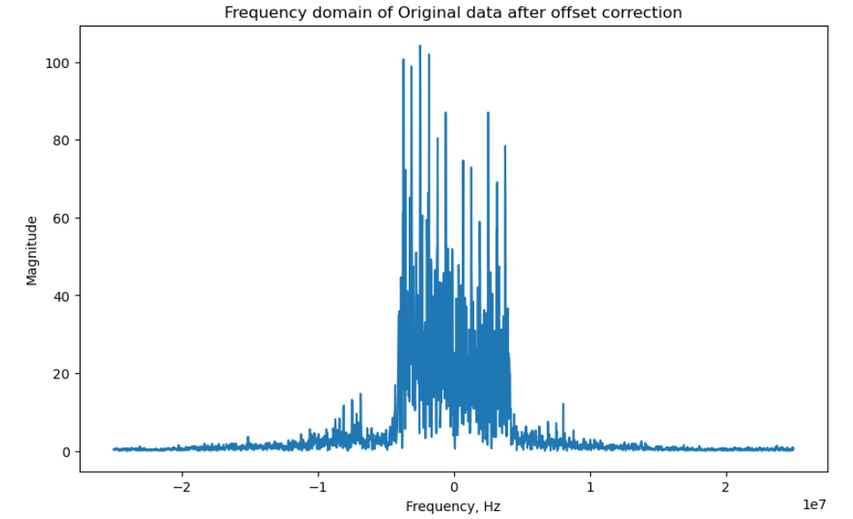

Peak Frequency Comparison Before and After Offset Correction
- I have compared the frequency spectra of the original and offset-corrected signals by calculating their FFTs and extracting the positive half of the spectrum. The peak frequencies of both signals were identified and marked on the plot. The resulting graph shows the frequency spectrum of the original signal and the corrected signal, with the peak frequencies before and after correction highlighted. This comparison provides a clear visualization of how the peak frequency changes after applying the offset correction.
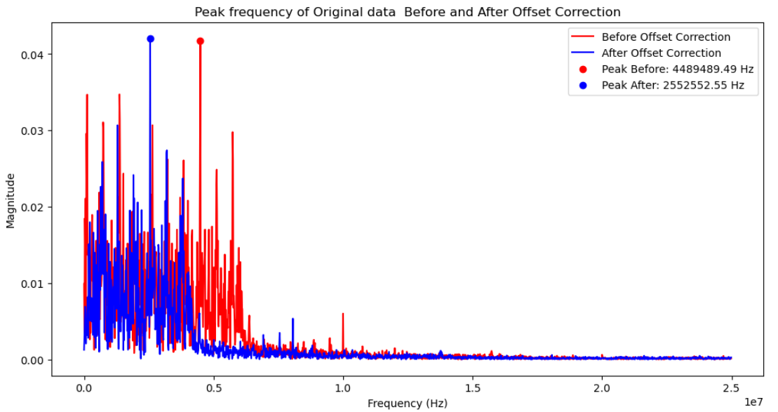

- Magnitude and Phase response of Orignal data after offset correction
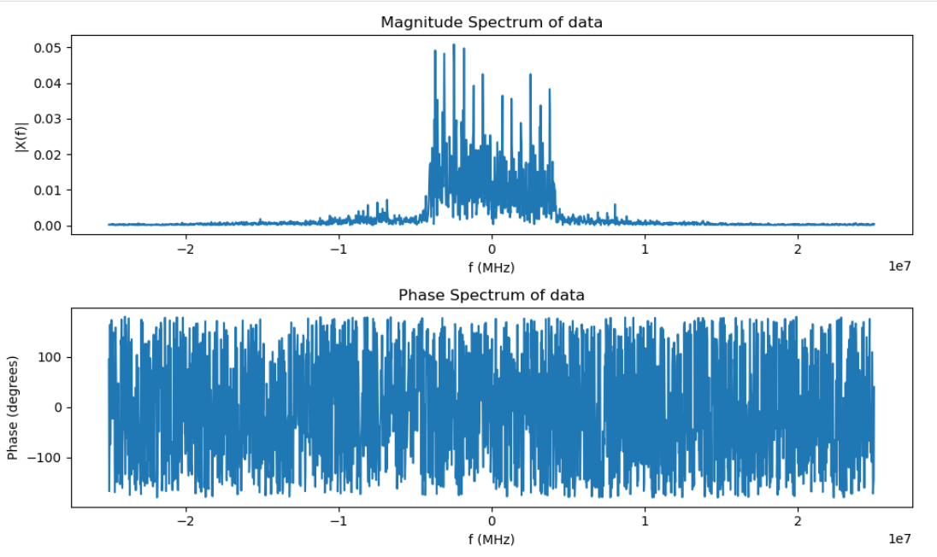
- Computed and plotted the FFT of the data, displaying both the magnitude and phase spectra. The magnitude spectrum shows the signal's strength across frequencies, while the phase spectrum indicates the phase shift at each frequency. Both plots use the frequency axis in MHz.

- Power Spectral Density of Original data after offset correction
- Analyze Signal Power Distribution: To understand how power is distributed across frequencies.
- Identify Noise Characteristics: To measure and analyze noise levels in specific frequency bands.
- Implemented a signal processing workflow to estimate and analyze the Power Spectral Density (PSD) of a signal using Welch's method
Code Implementation:
- Adapted a function (psd) that leverages SciPy's Welch method to calculate the PSD.
- Included options for customizing signal processing parameters like window type, segment length, overlap, and FFT size.
- Developed functionality to visualize the PSD with linear or logarithmic scaling.

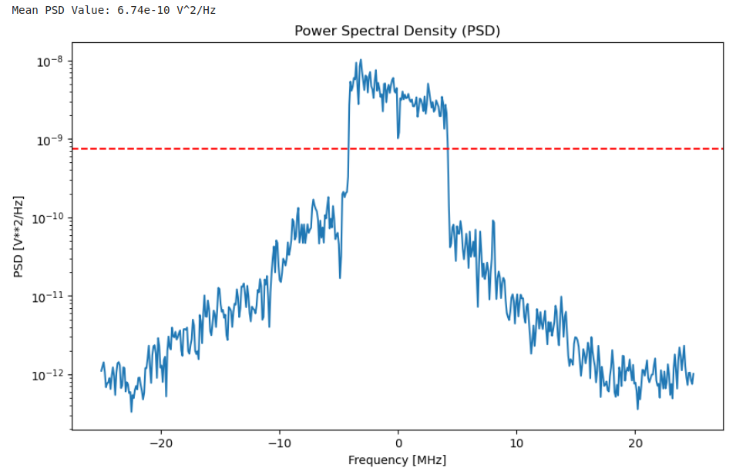

- Apply Low Pass Filter
- A low-pass filter allows frequencies below a certain cutoff to pass through while attenuating higher frequencies.

- Cutoff frequency =4.5 Mhz
Code Implementation:
- A Butterworth low-pass filter is designed and applied to the original signal to limit its frequency content to 4.5 MHz.
- The filter design uses scipy.signal.butter to generate the filter coefficients and scipy.signal.sosfiltfilt to apply the filter.
- The filtered signal and the frequency response of the low-pass filter are plotted to visualize the effect of filtering.
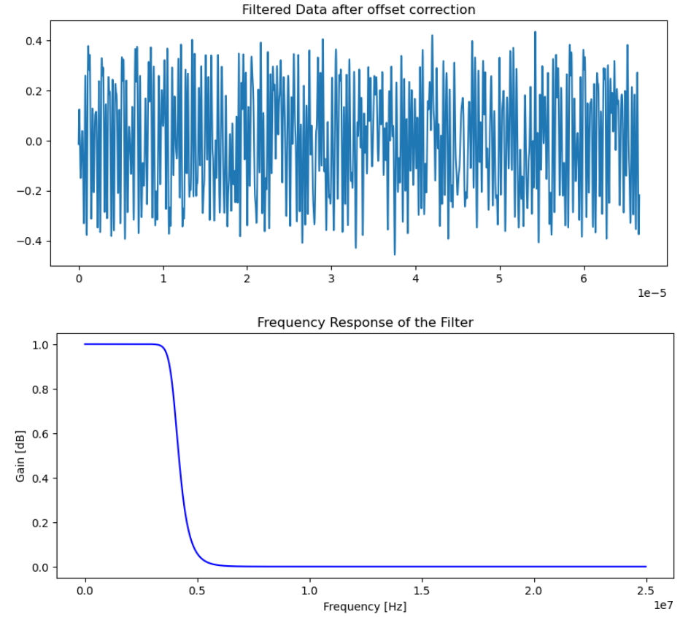

- Spectrogram of filtered data after offset correction
- Computed and plotted the spectrogram of the filtered data, which provides a time-frequency representation of the signal. The x-axis represents time (in seconds), the y-axis represents frequency (in Hz), and the color intensity indicates the signal's power (in dB) at each time-frequency point. This helps visualize how the signal's frequency content evolves over time.

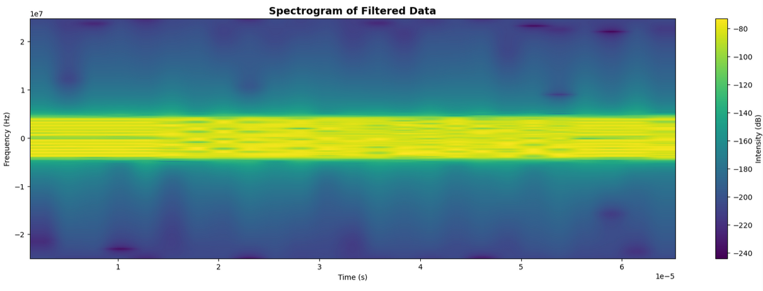
- Phase and group delay
- Phase and group delay are crucial concepts in signal processing, especially when analyzing how filters or systems affect the timing and integrity of signals

- The phase response of a system or filter describes how the phase of each frequency component is altered as the signal passes through. It indicates the phase shift introduced by the system to each frequency.
- How to Compute: The phase response is obtained from the frequency response of a filter:
H(ω)=∣H(ω)∣ejϕ(ω)
where ϕ(ω) is the phase response.
- The group delay measures how long it takes for each frequency component to travel through the system. It is defined as the negative derivative of the phase response with respect to angular frequency (ω):
τg​(ω)=−dω/dϕ(ω)​
- Group delay helps understand the timing of signals, especially in systems where different frequencies might experience different delays (a phenomenon called dispersion).
- How to Compute: Numerically, group delay can be approximated as the discrete derivative of the unwrapped phase response:

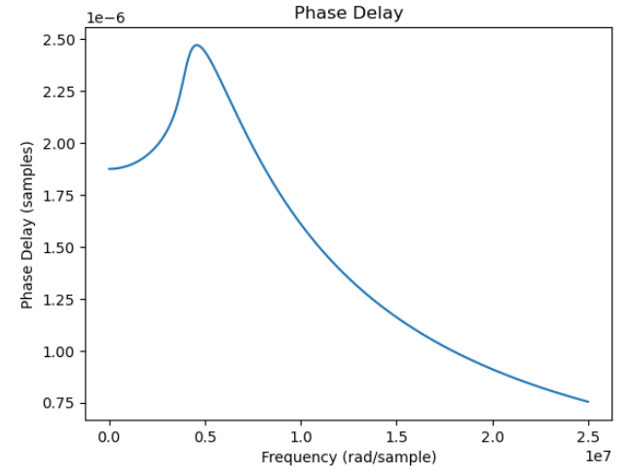
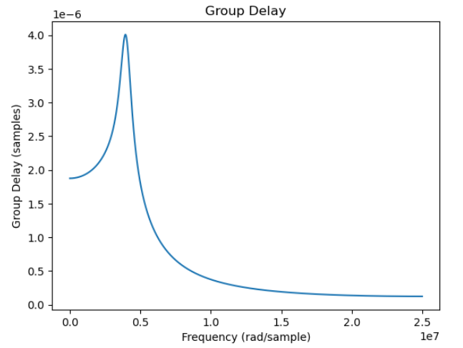

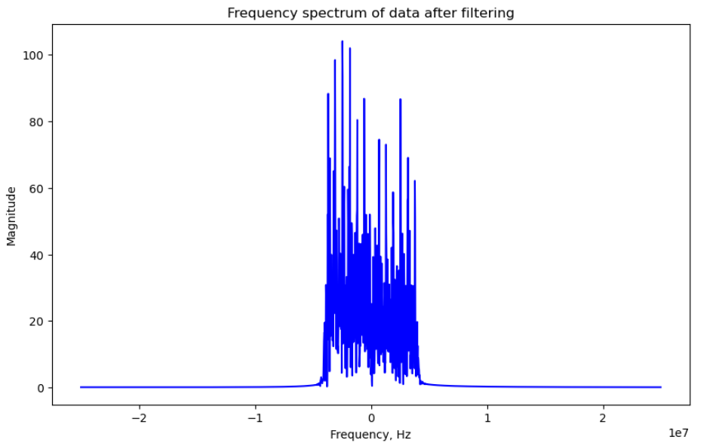
- Frequency spectrum after filtering

- Power Spectral Density after filtering

- Applied Welch's method to calculate and visualize the Power Spectral Density (PSD) of the filtered signal:
- This shows the power distribution of the filtered signal across frequencies.
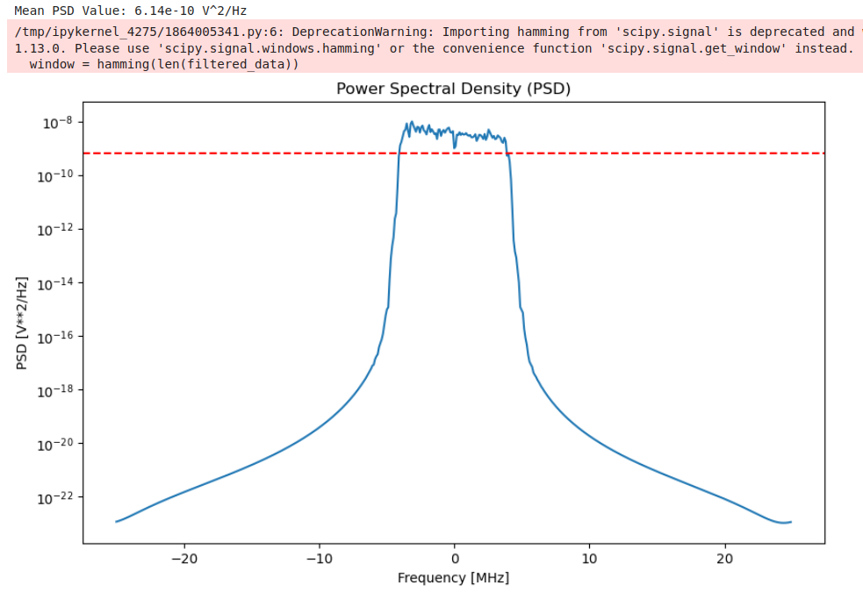

- Magnitude and Phase response After filtering
- Computed and plotted the FFT of the filtered signal, displaying both the magnitude and phase spectra. The magnitude spectrum shows the signal's strength across frequencies, while the phase spectrum indicates the phase shift at each frequency. Both plots use the frequency axis in MHz.

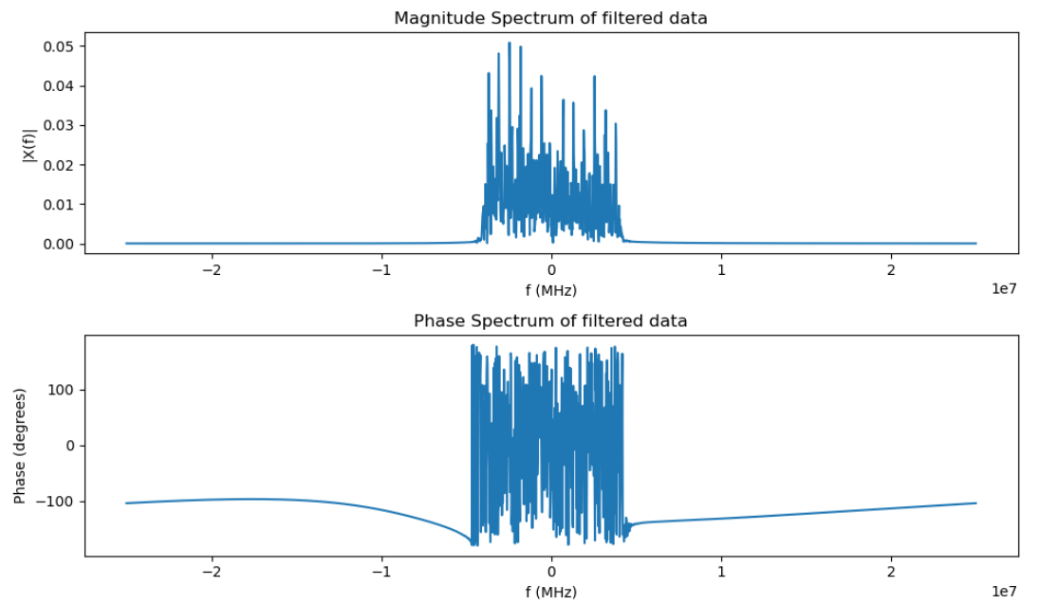

- Resampling After low pass filter
- Resampling adjusts the signal's sampling rate by downsampling (reducing rate).
Code Implementation:
- The filtered signal is resampled from the original sampling rate of 50 MHz to a target rate of 11 MHz using scipy.signal.resample.
- The resampling preserves the time duration of the signal.
- The resampled signal is plotted to confirm the successful downsampling process.
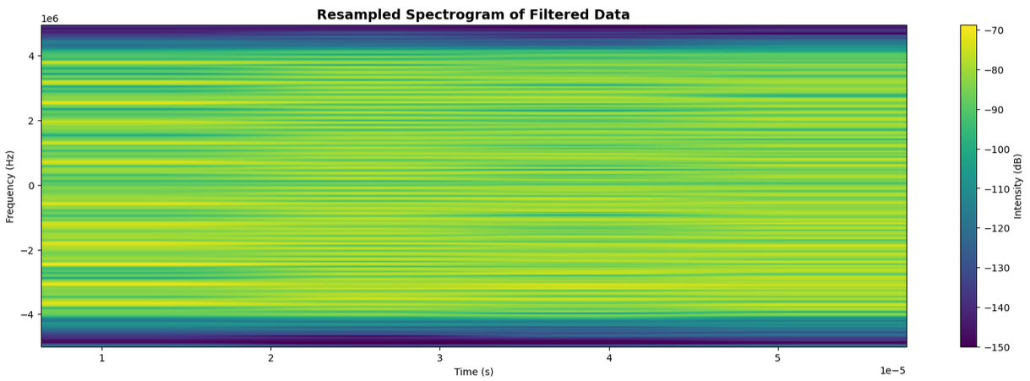
- Frequency spectrum after resampling
- Calculated the FFT of the resampled filtered data and plotted its frequency spectrum. The plot shows the magnitude of the signal across frequencies, providing insight into the frequency components of the filtered resampled data. The x-axis represents frequency in Hz, and the y-axis shows the signal's magnitude.
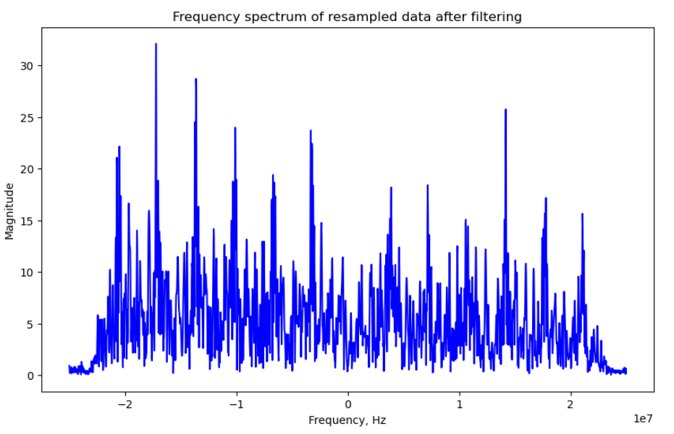

Power Spectral Density Of resampled data
- Used Welch's method to calculate the Power Spectral Density (PSD) of the resampled signal. After applying a Hamming window, I computed the PSD and shifted the frequency for better visualization. The mean PSD value was calculated and plotted on a logarithmic scale with frequency in MHz. This shows the power distribution of the resampled signal across frequencies.

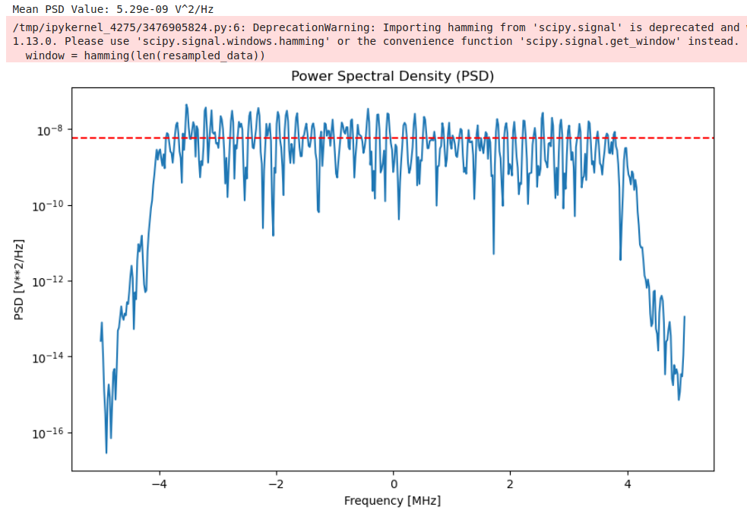

- Magnitude and phase response after resampling
- Computed and plotted the FFT of the resampled data after low-pass filtering, showing both the magnitude and phase spectra. The magnitude spectrum represents the signal strength across frequencies, and the phase spectrum displays the phase shift at each frequency, with the frequency axis in MHz.
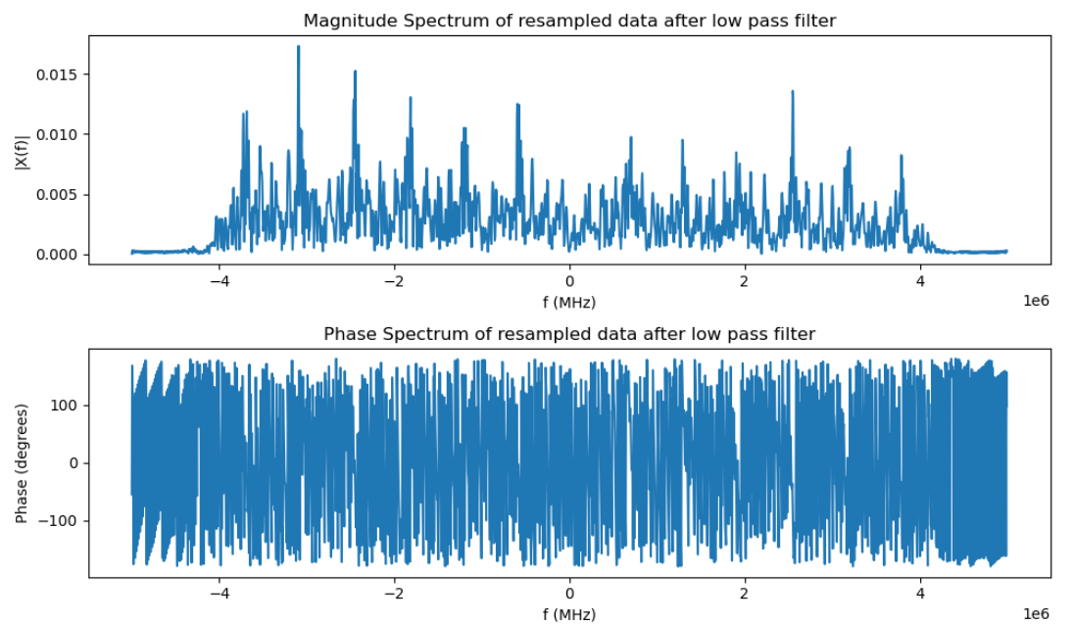

- SNR Calculation
- SNR of filtered data: 13.78 DB

Feature Extraction
The features_extraction() function extracts key time-domain and frequency-domain features from a signal:
- Time-domain features: Includes Min, Max, Mean, RMS, Variance, Standard Deviation, Power, Peak, Peak-to-Peak, Crest Factor, Skewness, Kurtosis, Form Factor, and Pulse Indicator.
- Frequency-domain features: Includes Max frequency component power, Total power, Average power, Frequency domain variance, Peak frequency value, Skewness, and Kurtosis.
It calculates these features using basic statistics and Fourier transform, then prints the results for both time and frequency domains. The function is used by passing signal data as a pandas DataFrame.

# TIME DOMAIN

Minimum amplitude of the signal: 0.006246381454292752
Maximum amplitude of the signal: 0.4815151091664386
Mean or Average Value of signal: 0.2752526970131824
Root mean square of the signal: 0.28969078353183964
Variance of the signal's amplitude: 0.008156702850260392
Standard Deviation of the signal's amplitude: 0.09031446645062126
Average power of the signal: 0.08392075006329117
Peak amplitude of the signal: 0.4815151091664386
Peak-to-Peak amplitude of the signal: 0.47526872771214584
Crest factor of the signal: 1.6621692388550418
Skewness of the signal's amplitude distribution: [-0.41501014]
Kurtosis of the signal's amplitude distribution: [-0.45074605]

# FREQUENCY DOMAIN

Maximum frequency component power: 6.962666677344363e-05
Total power in the frequency spectrum: 0.08392075006329118
Average power in the frequency spectrum: 2.5201426445432787e-05
Frequency domain variance: 2.0186020547612053e-10
Peak value of the frequency spectrum.: 6.962666677344363e-05
Skewness of the frequency spectrum: [0.26586342]
Kurtosis of the frequency spectrum: [-0.61988387]
Bandwidth Calculation:
To calculate the total bandwidth of a signal centered at zero frequency, multiply the cutoff frequency by 2 to account for both positive and negative frequencies. For a 4.5 MHz cutoff, calculate 2×4.5= 9 MHz as the total bandwidth. This approach is suitable for signals with symmetric frequency content around zero.
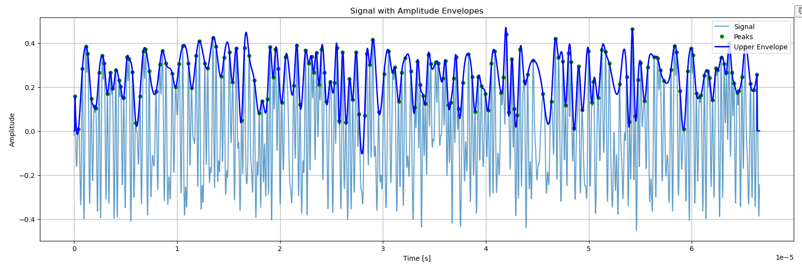
- Amplitude Envelop of filterd data
- Skewness and kurtosis visualization using KDE plot
